DAY 6: AUTOMATION & SCHEDULING FEATURES

Focus: Advanced Automation and Improved Scheduling System

Issues from Previous Day:
- Scheduler setting opposite device status instead of user defined status
- Device groupingnot running all devices properly (manual intervention required)
- No option to edit devices in smart scenes
- Limited scheduling options and poor user control

Development Activities
Scheduler Enhancement with UserDefined Status:
OLD CODE: Scheduler toggling opposite status
public void scheduleDevice(String deviceType, String roomName) {
Gadget device = findDevice(deviceType, roomName);
String oppositeStatus = device.getStatus().equals("ON") ? "OFF" : "ON";
scheduleAction(device, oppositeStatus); // Always opposite
}

NEW CODE: Userdefined status scheduling
public void scheduleDeviceWithStatus(String deviceType, String roomName) {
System.out.println("Current device status: " + getCurrentStatus(deviceType, roomName));
System.out.println("Select desired status for scheduling:");
System.out.println("1. Turn ON");
System.out.println("2. Turn OFF");

int choice = getValidatedChoice(1, 2);
String targetStatus = (choice == 1) ? "ON" : "OFF";

System.out.print("Enter schedule time (HH:MM): ");
String timeStr = scanner.nextLine();
LocalDateTime scheduleTime = parseScheduleTime(timeStr);

TimerTask task = new TimerTask();
task.setDeviceType(deviceType);
task.setRoomName(roomName);
task.setTargetStatus(targetStatus); // Userdefined status
task.setScheduledTime(scheduleTime);

timerService.scheduleTask(task);
System.out.println("Device scheduled to turn " + targetStatus + " at " + timeStr);
}

Device grouping Enhancement:
OLD CODE: Device grouping with manual device control issues
public class SmartScene {
private List<Gadget> devices;

public void executeScene() {
for (Gadget device : devices) {
// Inconsistent execution, manual intervention needed
controlDevice(device, "ON"); // Basic implementation
}
}
}

NEW CODE: Reliable Device grouping with batch execution
public class SmartScene {
private String sceneId;
private String sceneName;
private List<SceneAction> actions;
private String ownerEmail;

public static class SceneAction {
//logic
}

public SceneExecutionResult executeScene() {
System.out.println("Executing scene: " + sceneName);
SceneExecutionResult result = new SceneExecutionResult();

// Sort actions by execution order
actions.sort(Comparator.comparingInt(SceneAction::getExecutionOrder));

for (SceneAction action : actions) {
try {
//logic
} catch (Exception e) {
result.addFailure("Error controlling " + action.getDeviceType() + ": " + e.getMessage());
}
}

System.out.println("Scene execution completed:");
System.out.println("Successful: " + result.getSuccessCount());
System.out.println("Failed: " + result.getFailureCount());

return result;
}

public void editSceneDevices() {
System.out.println("Editing devices in scene: " + sceneName);
System.out.println("Current devices:");

for (int i = 0; i < actions.size(); i++) {
SceneAction action = actions.get(i);
System.out.printf("%d. %s in %s Action: %s%n",
i + 1, action.getDeviceType(), action.getRoomName(), action.getAction());
}

System.out.println("\nOptions:");
System.out.println("1. Add new device to scene");
System.out.println("2. Remove device from scene");
System.out.println("3. Modify device action");
System.out.println("4. Change execution order");

int choice = getValidatedChoice(1, 4);
switch (choice) {
case 1: addDeviceToScene(); break;
case 2: removeDeviceFromScene(); break;
case 3: modifyDeviceAction(); break;
case 4: changeExecutionOrder(); break;
}
}
}

Scene Management Service: User can select the scene to automate the devices.

Bug Fixes Implemented:
1. Scheduler Status Selection Fixed
Users can now choose specific device status (ON/OFF) when scheduling
Removed automatic opposite status toggling
Added current status display for better user decision making

2. Device groupingExecution Fixed
Reliable batch execution of all devices in scene
Proper error handling and retry logic
Sequential execution with optional delays between actions

3. Scene Device Management Fixed
Added ability to edit devices within existing scenes
Device addition, removal, and modification options
Execution order management for coordinated control

New Features Added:
1. Advanced Scheduling Options
Userdefined device status for scheduling
Recurring schedule support
Multiple device scheduling in single operation

2. Enhanced Smart Scenes
Scene execution result tracking
Device execution order management
Scene templates for common automation patterns

Testing screen shots:
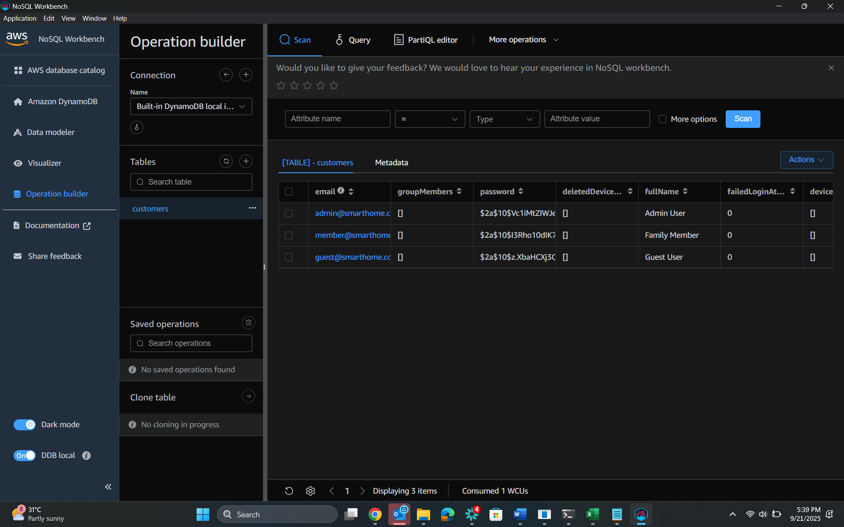

Conclusion Day 6:
Successfully resolved critical automation issues with scheduler status selection and smart scene execution. Enhanced the automation system with user controlled scheduling and reliable scene management capabilities.

Key Achievements:
- Fixed scheduler to accept user defined device status
- Resolved smart scene execution reliability issues
- Added comprehensive scene editing capabilities
- Enhanced automation control and user experience

